Weldon Public Library District
Calendar of Events Summer Reading 2019
“It’s Showtime at Your Library!”
Wednesday  June 12th  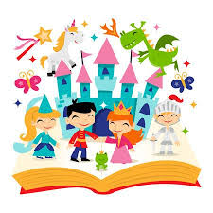  10:30-11:30  “Fairy Tale”  Adventures | Wednesday  June 19th  10:30-11:30  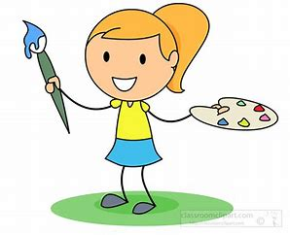  “Clay Creations” | Wednesday  June 26th  10:30-11:30  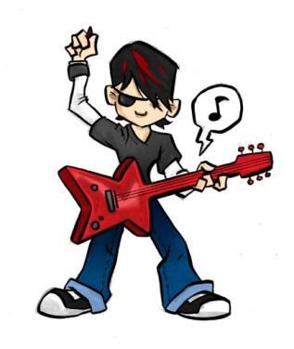  Be a “Rock Star” | Wednesday  July 3rd  10:30-11:30  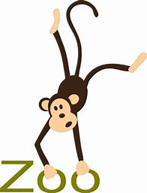  “Scovill Zoo” | Wednesday  July 10th  10:30-11:30  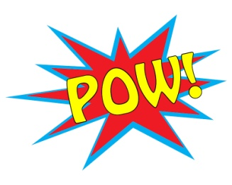  Be a “Superhero” | Wednesday  July 17th  7:00 pm  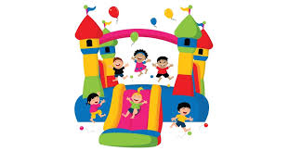  Awards Party

AWARDS PARTY
Bounce House Fun
Wednesday July 17th 7:00 p.m.
Registration begins May 24th
All children are invited to participate.
Reading will begin May 24th and end with an Awards Party on July 17th at 7:00 p.m.
Weekly Programs begin June 12th 10:30 a.m. – 11:30 a.m.
All Readers will read at their own pace!
Kids/Parents will keep track of the pages read on the Reading log.
All kids will receive prizes, snacks and enjoy a morning of Fun & Activities!
Any questions call 736-2215

