Weldon Public Library District
Calendar of Events Summer Reading 2020
“Dig Deeper: READ, INVESTIGATE, DISCOVER!”
"TAKE & MAKE"  DINOSAURS  June 9th  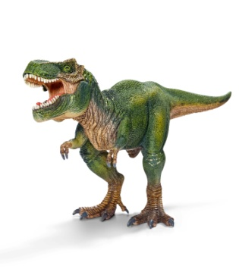 | "TAKE & MAKE"  “ROBOTS”  June 16th | "TAKE & MAKE"  "SPY"  June 23th  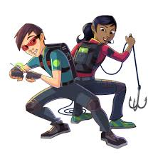 | "TAKE & MAKE"  “NATURE"  June 30th | "TAKE & MAKE"  "MUMMY"  July 7th  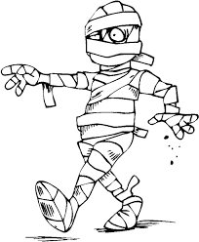 | "TAKE & MAKE"  "OUTERSPACE"  July 14th

Registration begins May 26th
All children are invited to participate.
Weekly "TAKE & MAKE" Bags begin June 9th
(Your bags will include Crafts, Activities, Toys and a fun yummy Snack!)
All Readers will read at their own pace!
Kids/Parents will keep track of the pages read on the Reading log, library staff will be checking in to get a weekly tally.

Any questions call 736-2215

